1. **Services**
2. **Mailing**

Our system now supports both [sendgrid](https://sendgrid.com/) and [sparkspot](https://www.sparkpost.com/). Just select 1 service you want

1. [**Sendgrid**](https://sendgrid.com/)

* Register and login to dashboard
* In the left menu > Settings > API keys

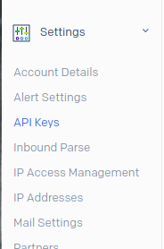

* Click create new API key
* Select permission for this API key (usually Full access)
* After create successfully, you will get API Id and API Key

1. [**Sparkspot**](https://www.sparkpost.com/)

* All information how to setup Sparkspot please check from [their document](https://www.sparkpost.com/docs/getting-started/getting-started-sparkpost/)
* After login, please check Settings > Api keys

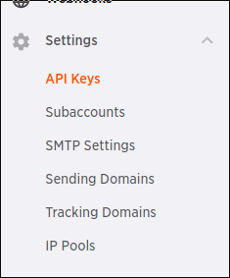

* Click create API key and get it

1. **SMS**

We are using [Twillio](https://www.twilio.com/) for SMS service. Use to verify user account, verify COD

* Register and login to Twllio account
* Create new project by clicking Drowndown in the top and select Create new project option or go to this [link](https://www.twilio.com/console/projects/create)

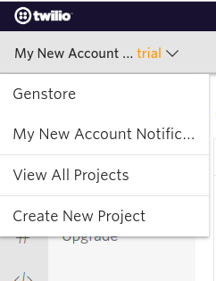

* Select Product tab and click on Programmable SMS, then click Continue buton

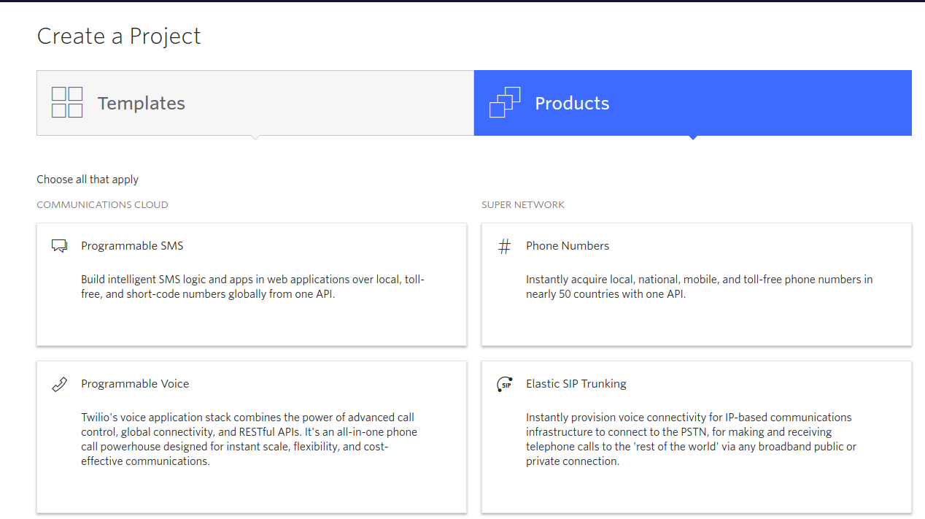

* Fill your app name and information, then so on
* Select your project at the top. In the app dashboard you will see ACCOUNT SID and AUTH TOKEN. Save it

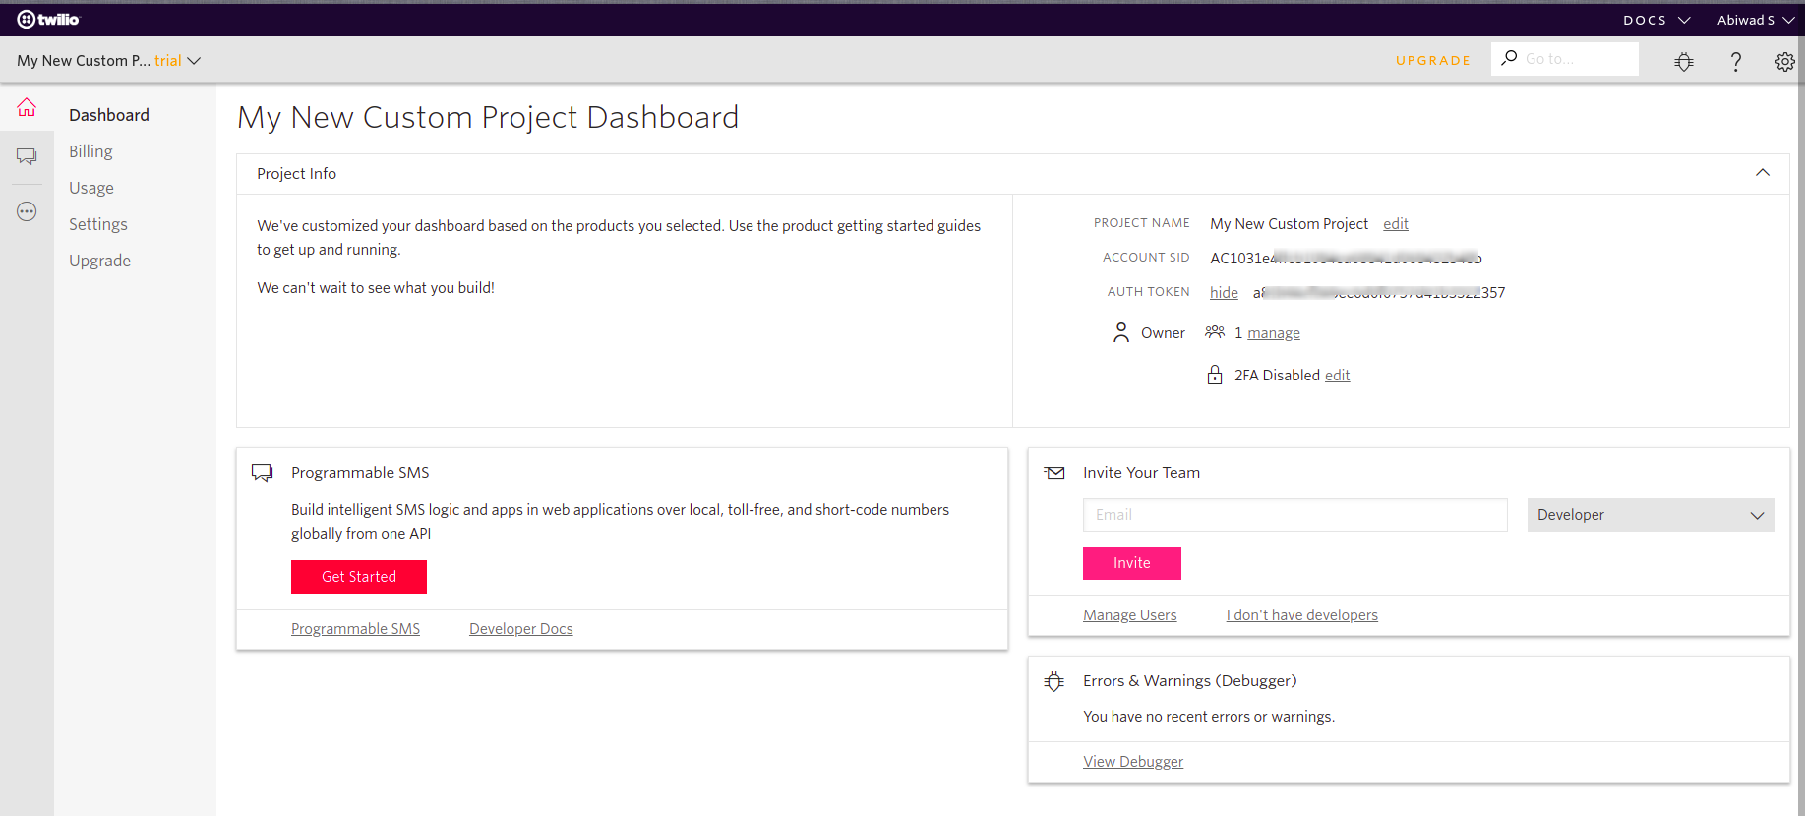

* In the left, click … and select Programmable SMS

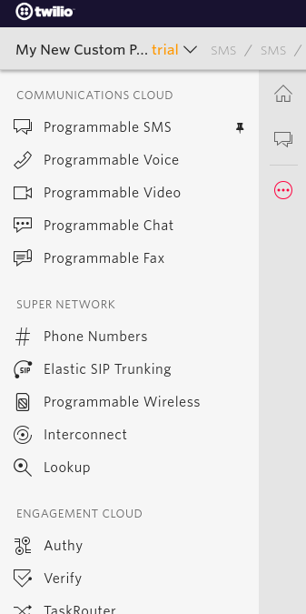

* Click Create new Messessing Service buton and Select Marketing - Outbound only then Click Create

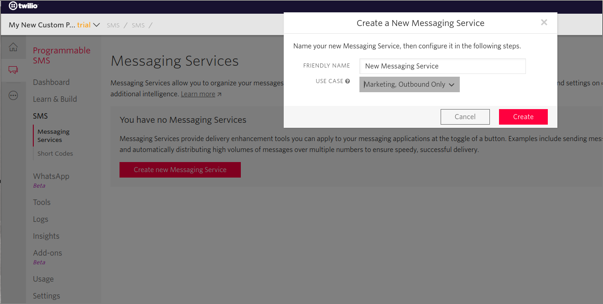

* After created, Select Numbers menu under Programmable SMS

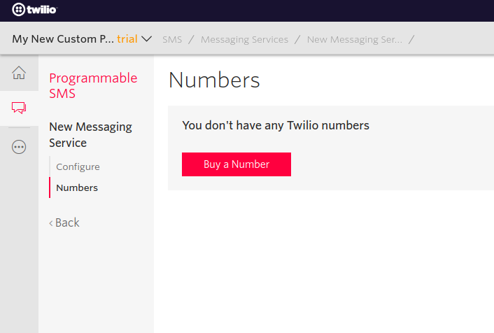

* Buy your number and store. The number is up to you. Look like +13232xxxxx

1. [**Paypal**](https://www.paypal.com)

* Register Paypal account and register developer account
* Go <https://developer.paypal.com/> and login
* In the left sidebar, click My Apps & Credentials

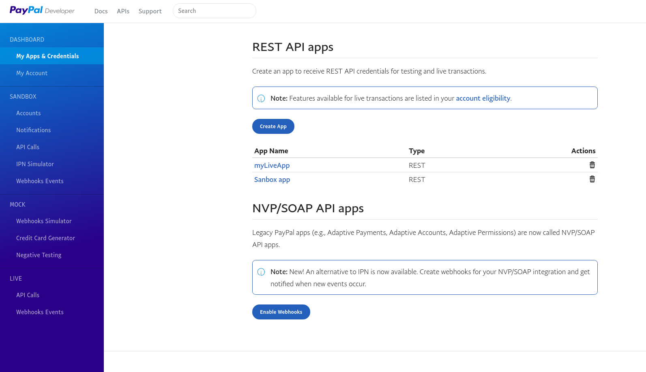

* Create new app or edit

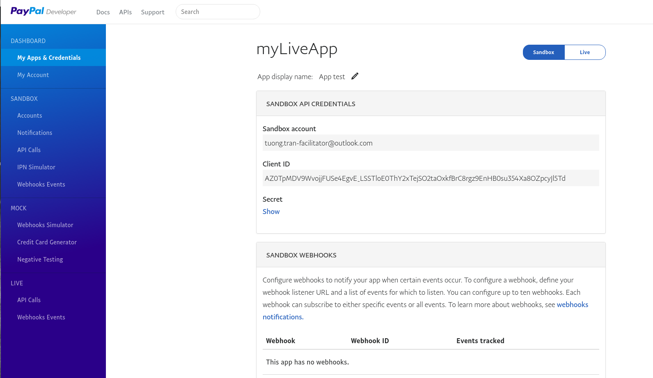

* Toggle Sandbox (test mode) or Live (production mode)
* Click Show button under Secret.
* Copy client Id, secret